**Capstone Project:**

**Analytical CRM Development for a Bank**

**Introduction:**

This comprehensive project aims to analyse customer data provided by a bank to understand customer churn (customer loss). We'll identify key factors driving churn, develop actionable insights to improve customer retention, and ultimately enhance customer satisfaction. By leveraging various tools like Excel, Power BI, and SQL, we'll gain a deeper understanding of customer behaviour and preferences.

**Objective:**

The primary objective of this project is to reduce customer churn and enhance customer satisfaction for the bank. This will be achieved through:

1. Identifying key factors contributing to customer churn.

2. Developing insights to improve customer retention strategies.

3. Enhancing service delivery based on customer preferences and behavior.

**Introduction to Data**

The bank has provided several datasets related to customers, including:

* Customerid**:** A unique identifier for each customer.
* CreditScore**:** A numerical representation of the customer's creditworthiness.
  + **Credit score:** 
    - Excellent: 800–850
    - Very Good: 740–799
    - Good: 670–739
    - Fair: 580–669
    - Poor: 300–579
* GeographyID**:** A numerical identifier that likely corresponds to a geographical location, such as a country or region.
* GenderID**:** A numerical identifier for the customer's gender, where for example, '1' could represent male and '2' could represent female.
* Age**:** The age of the customer.
* Tenure**:** The number of years the customer has been with the bank.
* Balance**:** Current balance in the customer's account.
* Num Of Products: refers to the number of products that a customer has purchased through the bank.
* HasCrCard: denotes whether or not a customer has a credit card. This column is also relevant, since people with a credit card are less likely to leave the bank.
  + - 1 represents credit card holder
    - 0 represents non credit card holder

* **IsActiveMember:** active customers are less likely to leave the bank (as per the criteria defined by the bank for identifying the activeness).
  + - 1 represents Active Member
    - 0 represents Inactive Member
* **Estimated Salary:** as with balance, people with lower salaries are more likely to leave the bank compared to those with higher salaries.
* **Exited:** whether or not the customer left the bank.
  + - 0 represents Retain
    - 1 represents Exit
* **Bank DOJ:** date when the Customer associated/joined with the bank.

**Data Exploration**

* **Data Sources:** We'll meticulously examine the provided datasets, including customer demographics, account details, account activity, and potentially additional data relevant to churn.
* **Data Understanding:** We'll delve into the meaning and significance of each data point within the datasets. This includes understanding data types (numerical, categorical, etc.) and identifying any potential issues like inconsistencies or missing values.
* **Data Visualization:** Initial data visualizations using tools like histograms and scatter plots will provide a preliminary glimpse into data distribution and potential relationships between variables.

**Data Preprocessing**

**1. Data Cleaning in Excel/Power BI**

* **Missing Value Imputation:** We'll strategically address missing data points using techniques like mean/median imputation for numerical data or mode imputation for categorical data.
* **Error Correction:** We'll meticulously identify and rectify any data errors like typos, outliers, or inconsistencies in date formats or currency representations.
* **Data Standardization:** We'll ensure data consistency by standardizing formats across datasets. This might involve converting date formats (e.g., MM/DD/YYYY) and potentially converting currencies to a single unit for analysis.
* **Feature Engineering:** We'll create new features from existing data if necessary. Examples include calculating customer age groups, time since joining the bank (tenure in years) based on historical transactions.

**2. Data Transformation in SQL**

* **Database Schema Design:** We'll design a well-structured relational database schema in SQL to efficiently store and manage the combined customer data. This schema will optimize data retrieval and manipulation for analysis.
* **Data Cleaning Queries:** We'll utilize powerful SQL queries to further clean and manipulate data. This includes addressing missing values using functions like AVG(), MEDIAN(), or COALESCE(), transforming data formats (e.g., converting strings to dates), and calculating derived attributes like churn rate by demographics using aggregation functions like COUNT() and GROUP BY.

**Creating Columns with DAX (Power BI)**

DAX (Data Analysis Expressions) is a powerful formula language used in Power BI to create calculated columns and measures. Here are some potential DAX column examples:

**Calculated Measures**

Measures are dynamic calculations created within Power BI to summarize d data. Here are the explanations for the provided measures:

Churn_Rate=DIVIDE(calculate(countrows(‘bank_churn’),’bank_churn’[Exited]=1),

Calculate(countrows(‘bank_churn’),’bank_churn’[Exited] = 0 || ‘bank_churn’[Exited] = 1),0)*100

**Calculated Columns**

Calculated columns extend your data's capabilities by creating new data points derived from existing information. They offer valuable insights and simplify data exploration. Here is a breakdown of the available calculated columns:

* **AgeBrackets (CustomerInfo table):** This column segments customers into age groups using a nested IF statement:
  + "Adult": Age 30 or younger.
  + "Middle-Aged": Between 31 and 50 years old.
  + "Old-Aged": Above 50 years old.  
    AgeBrackets = IF(CustomerInfo[Age]<=30,"Adult",IF(CustomerInfo[Age]<=50,

"Middle-Aged","Old-Aged"))

* **SalarySegments (CustomerInfo table):** This column segments customers based on their estimated salary using a nested IF statement:
  + "Poor": Below 20,000.
  + "Lower Middle Class": 20,000 to 50,000.
  + "Upper Middle Class": 50,000 to 100,000.
  + "Rich": Exceeding 100,000 (thresholds can be adjusted).  
    CustomerSegments = IF(CustomerInfo[EstimatedSalary]<20000,"Poor",  
    IF(CustomerInfo[EstimatedSalary]<50000,"Lower MiddleClass",  
    IF(CustomerInfo[EstimatedSalary]<100000,"Upper Middle Class","Rich")))
* **YEARDOJ** = YEAR(CustomerInfo[Bank DOJ])

* **Status (CustomerInfo table):** This column classifies customers as "New Customer" or "Old Customer" based on their bank joining year (BankDOJ) using an IF statement and the YEAR function. The specific year defining a "New Customer" can be adjusted.  
  Status = IF(year(CustomerInfo[BankDOJ])=2019,"New Customer","Old Customer")
* **CreditCardsPerBucket** (**Bank_churn**):=
* CALCULATE( [CustomersWithCreditCard],
* GROUPBY('customerinfo', 'customerinfo'[AgeBrackets])
* **Customertype(Bank_churn):** This column classifies as “Long_term” or “New”
* **Customertype:**  = IF(Bank_Churn[Tenure] >=4, "Long_term","New")
* **CustomerCategory(Bank_churn) =** This column classifies customer category as “new customer”,”old customer” by using if statement and the tenure function

**CustomerCategory =** IF ( 'Bank_Churn'[Tenure] > 4,"Older Customer","New Customer")

* **ChurnRisk(Bank_churn):** This column specifies that how the bank churn is their in risk of high or low by using the if statement and the Tenure function

**ChurnRisk** = IF('bank_churn'[Tenure] < 4, "High Risk", "Low Risk")

**Objective Questions:**

**1.** **What is the distribution of account balances across different regions?**

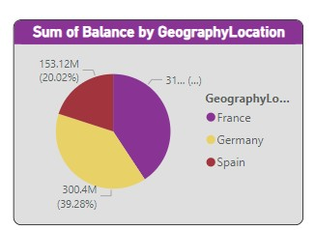

As we can see, France, Germany, and Spain have a large client base. In light of this, the account balances are as well quite high in France, Germany, and Spain, in that order

**2 Identify the top 5 customers with the highest Estimated Salary in the last quarter of the year. (SQL)**

This SQL query identifies the top 5 customers with the highest estimated salary who joined the bank in the last quarter (quarter 4) of the year.

* Filters data for customers joining in the fourth quarter(where extract (Quarter from BANKDOJ) = 4).
* Sorts by estimated salary in decreasing order (order by estimatedsalary DESC).
* Limits result to the top 5 customers (LIMIT 5)

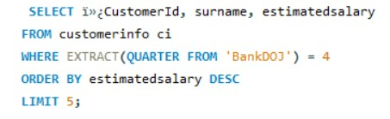

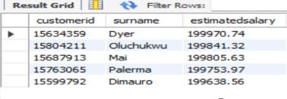

**3** **Calculate the average number of products used by customers who have a credit card. (SQL)**

* Filter data form customers with a creditcard
* Calculates the average number of products for those customers (AVG(numofproducts)).

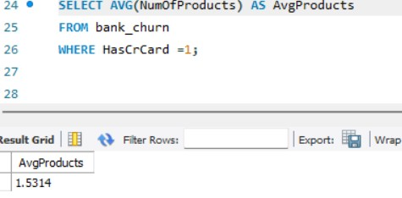

AVG product of Bank_churn is 1.5314

**4.** **Determine the churn rate by gender for the most recent year in the dataset.**

Interact with the stacked bar to view churn rates specifically for male or female customers within the selected year.

This provides insights into potential gender disparities in churn rates. Consider including a chart for better visualization

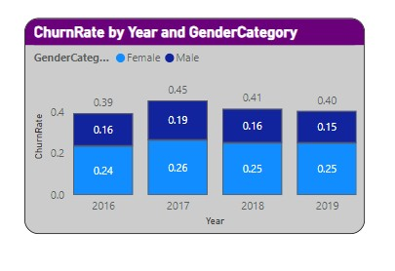

**5.Compare the average credit score of customers who have exited and those who remain. (SQL)**

This SQL query compares the average credit score of customers who exited the bank (Exited = 1) with those who remain (Exited = 0).

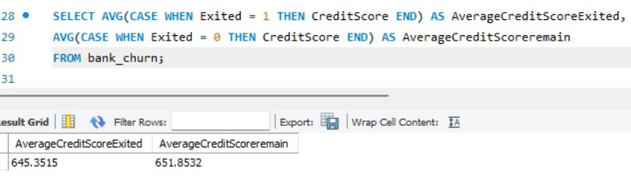

* And the Averagecreditscore EXITED is 645.3515
* And the Averagecreditscore REMAIN is 651.8532

**6.Which gender has a higher average estimated salary, and how does it relate to the number of active accounts? (SQL)**

* This query compares average estimated salary between genders and explores its relation to the number of active accounts
* Join the gender to gendered
* Join bank_churn to the customer ID
* Where is active member = 1
* Group by GenderCategory

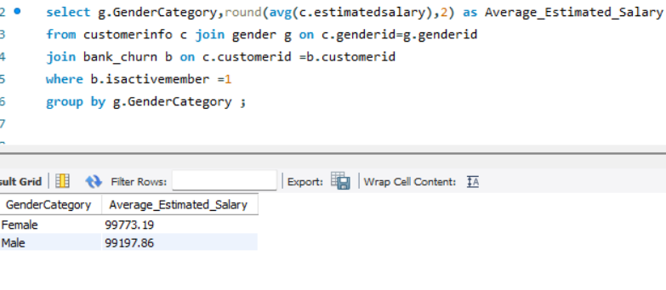

**7.Segment the customers based on their credit score and identify the segment with the highest exit rate. (SQL)**

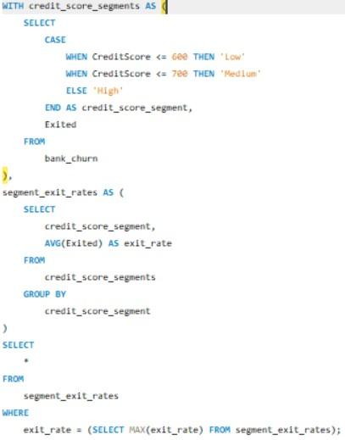

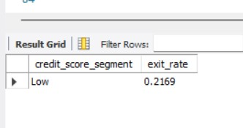

**8. Find out which geographic region has the highest number of active stomers with a tenure greater than 5 years. (SQL)** This query finds the geographic region with the highest number of active customers who have been with the bank for more than 5 years (tenure).

* It joins three tables:
  + grographyfor customer location data.
  + customerinfo (c) to link customer IDs to geographic locations.
  + bank_churn (b) for customer activity and tenure information.
* It filters for customers with a tenure greater than 5 years (b.tenure > 5).
* It groups by geographylocation and counts active customers using COUNT(b.customerId).

It orders by active_customers descending and uses to show the region with t 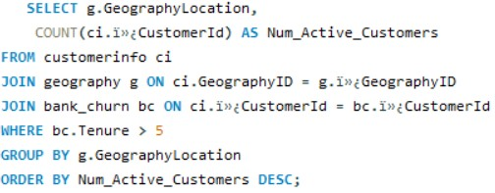

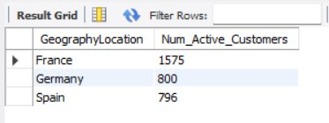

**9. What is the impact of having a credit card on customer churn, based on the available**

**Data?**

The chart reveals a potentially churn rate of credit card and non credit card

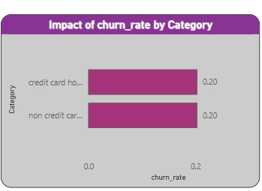

**10.For customers who have exited, what is the most common number of products they have used?**

Based on the bar chart you described, it appears to show the distribution of the number of products used by customers who have exited the bank ( churned). The x-axis represents the number of products used, and the y-axis represents the count of customers who used that many products.

Key Insights:- The most common number of products used by exiting customers is 1. This suggests that a significant portion of customers who churned had only used a single product.

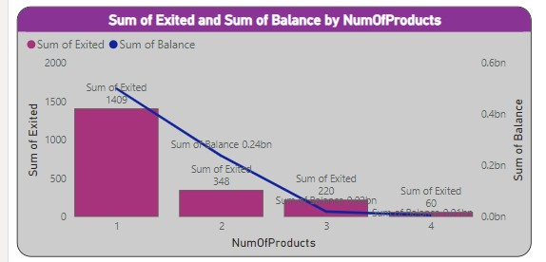

**11 .Examine the trend of customer exits over time and identify any seasonal patterns (yearly or monthly). Prepare the data through SQL and then visualize it.**

Based on the chart you described, it appears to be a time series graph showing the count of customers joining the bank over time, likely year Here's a breakdown of the key insights and a short explanation for your document:

Key Insights:- Overall Trend: The customer joining trend appears to be increasing over time. This indicates a positive growth in customer acquisition.

Possible Seasonality: There might be seasonal patterns present in the data. It seems that customer joins could potentially peak around the end of the year (December) but due to the limited data points, it's difficult to confirm a strong seasonal trend.

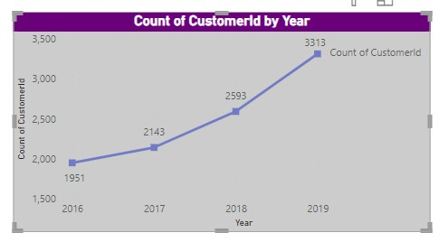

12.Analyze the relationship between the number of products and the account balance for customers who have exited.

Based on the bar chart we described, it appears to show the distribution of the number of products used by customers who have exited the bank (churned). The x-axis represents the number of products used, and the y-axis represents the count of customers who used that many products.

Key Insights:

* The most common number of products used by exiting customers is 1. This suggests that a significant portion of customers who churned had only used a single product.
* There's a general downward trend as the number of products used increases. This suggests that customers who churned tend to have

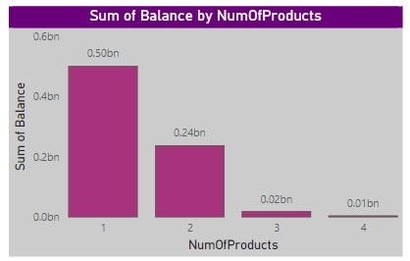

13.Identify any potential outliers in terms of balance among customers who have remained with the bank.

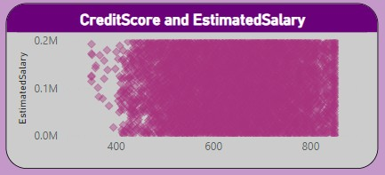

We are identifying potential outliers in terms of account balance among customers who have remained active with the bank (not churned). Here's a breakdown of the method and some insights.

As we can see from the above scatter plot graph: The estimated salary with the balance 0.0M to 0.2M is potential outliers as Outlier are the one which is abnormally have distance compare to the other value in our sample dataset As we can see creditscore 400 to 800 and the creditscore is higher end at estimated salary .

14.How many different tables are given in the dataset, out of these tables which table only consists of categorical variables?

* There are 7 different tables in the data set, the tables that consist of only categorical values are ActiveCustomer,Bank_Churn,CreditCard,CustomerInfo,ExitCustomer,Gender,Geography.Tables with Categorical Variables:
* CustomerInfo:Contains categorical variables like Surname.
* Exit Customer: Contains categorical variables like Exit Category(Exit ,Retain).
* Gender: Contains categorical variables like Gender Category (Male,Female).
* Geography: Contains categorical variables like Geography Location (France, Spain, Germany).
* ActiveCustomer: Contains categorical variables like Active Category (Active Member , Inactive Member).
* CreditCard: Contains categorical variables like Category (Credit-card holder , Non-Credit card holder)

15.Using SQL, write a query to find out the gender-wise average income of males and females in each geography id. Also, rank the gender according to the average value. (SQL)

This SQL code calculates the average income (estimated salary) for males and females within each geographic ID and assigns a rank based on the average salary.

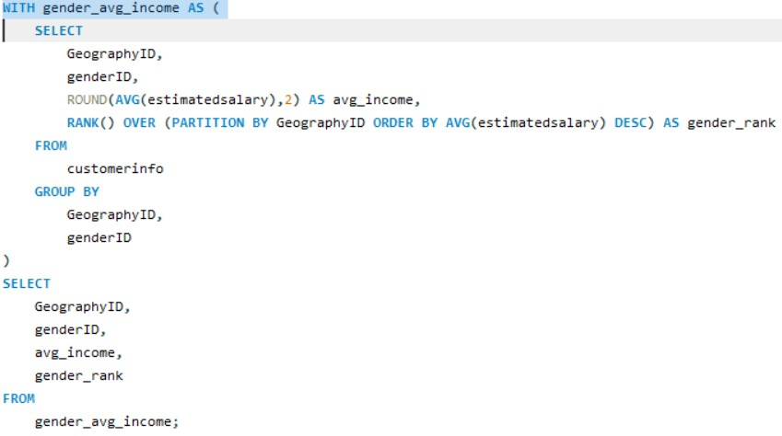

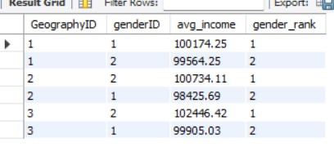

16.Using SQL, write a query to find out the average tenure of the people who have exited in each age bracket (18-30, 30-50, 50+).

This SQL query calculates the average tenure (time with the bank)   
of exited customers (Exited = 1) categorized into age brackets (18-30, 31-50, 50+) to understand churn patterns across different age groups.

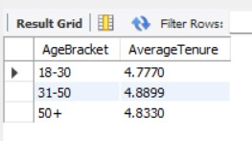

17.Is there any direct correlation between salary and the balance of the customers? And is it different for people who have exited or not?

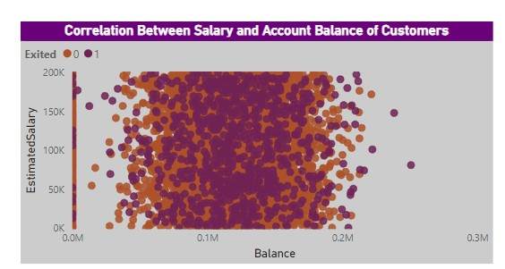

18.Is there any correlation between the salary and the Credit score of customers?

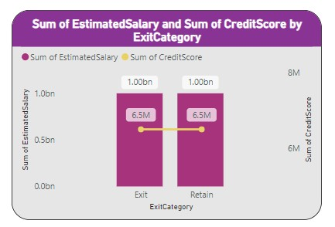

19.Rank each bucket of credit score as per the number of customers who have churned the bank.

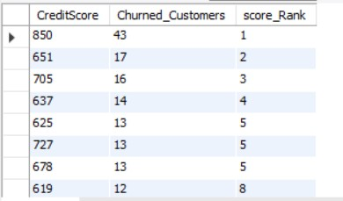

20.According to the age buckets find the number of customers who have a credit card. Also

retrieve those buckets that have lesser than average number of credit cards per bucket. This query helps identify age groups with a lower than average credit card ownership rate. By analyzing these segments, you can gain insights into customer behavior and potentially develop targeted marketing campaigns to promote credit card adoption within these age groups.

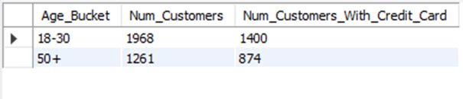

21. Rank the Locations as per the number of people who have churned the bank and average balance of the customers.

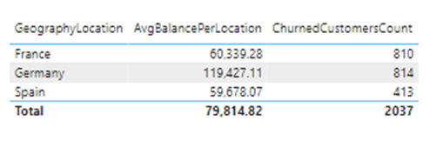

22.As we can see that the “CustomerInfo” table has the CustomerID and Surname, now if we have to join it with a table where the primary key is also a combination of CustomerID and Surname, come up with a column where the format is “CustomerID_Surname”.

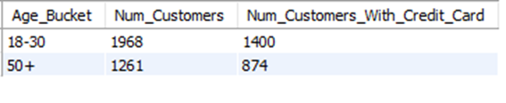23.Without using “Join”, can we get the “ExitCategory” from ExitCustomers table to Bank_Churn table? If yes do this using SQL.

This code retries data from the bank churn table and adds a new column named “Exit category” to classify customers

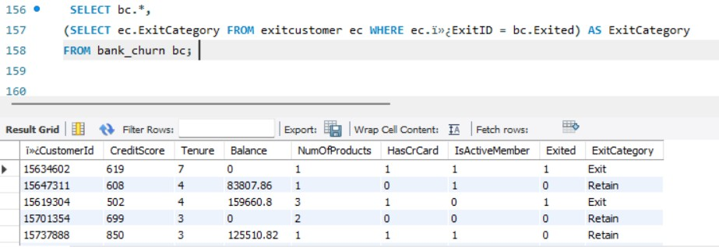

24.Were there any missing values in the data, using which tool did you replace them and what are the ways to handle them?

* We made sure to find and fix any missing information in the dataset using Power Query Editor in Power BI.
* We checked for and took care of any empty cells or spots where data was missing
* Whenever we found missing values, we either filled them in with specific values we already knew or copied values from nearby cells that had information.
* By doing this, we ensured that our analysis was based on complete data, making our insights from the dataset more accurate.
* then utilized the editor's functionalities to replace these missing values either with a predefined value or by filling them with the value from the preceding non-blank cell.

25.Write the query to get the customer IDs, their last name, and whether they are active or not for the customers whose surname ends with “on”.

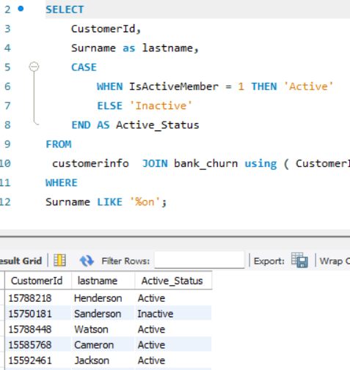

Retrieve the CustomerID, last name, and active status of customers whose last name ends with "on" using this query.

With the help of a CASE statement, the query determines the customer's status based on the Is Active column value (1 for active, 0 for inactive).

**Subjective Question:**

1. **Customer Behaviour Analysis: What patterns can be observed in the spending habits of long-term customers compared to new customers, and what might these patterns suggest about customer loyalty?**

This analysis examines the spending patterns of new and long-term customers to understand customer loyalty. We have created three charts to identify trends in average balance, salary, and number of products held by both customer groups.

Let's delve into the key insights revealed by the first chart focusing on average balance.  
 Based on the graph, the average balance of new customers seems to be consistently lower than that of long-term customers. This suggests that long-term customers tend to spend more money with the bank over time.

Here’s a more detailed analysis of the graph:

* The y-axis shows the average balance.
* The x-axis shows the month.
* The blue line represents new customers and the orange line represents long-term customers.
* There is no consistent pattern for new customers. Their average balance fluctuates throughout the year.
* Long-term customers, on the other hand, generally show an increasing average balance over time. Their average balance starts lower than new customers in January, but surpasses it by March and continues to climb throughout the year.

However, the overall trend suggests that customers tend to spend more money with the bank the longer they are customers. This could be for a number of reasons, such as:

* Long-term customers may have become more familiar with the bank’s products and services and found more products to use.
* Long-term customers may have increased their income over time, allowing them to save more money.
* The bank may offer better interest rates or other benefits to long-term customers, which could incentivize them to save more money with the bank.

Understanding these customer spending habits can help the bank develop targeted marketing campaigns to attract new customers and retain existing ones.  
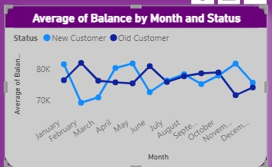

The second chart shows the average salary by month and customer status (new vs. old customers). Here are some key insights from this chart:

* Generally higher salaries for long-term customers: The average salary for long-term customers (orange line) appears to be consistently higher than that of new customers (blue line) throughout the year. This could be due to several factors, such as long-term customers receiving salary increases over time, or new customers starting out in their careers with lower salaries.
* Possible salary increases for new customers: While the average salary starts lower for new customers, there seems to be a slight upward trend throughout the year. This could suggest that new customers are getting raises or finding higher-paying jobs as time goes on.

Overall, this chart suggests a correlation between customer status and salary. Long term customers tend to have higher average salaries, and new customers may experience salary increases over time.

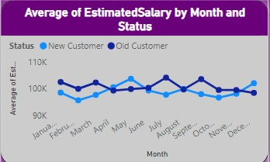

The third chart shows the average number of products held by new and long-term customers over the course of a year. Here are some key insights:

* Long-term customers tend to hold more products**:** The average number of products held by long-term customers (orange line) is consistently higher than that of new customers (blue line) throughout the year. This suggests that customers tend to acquire more products and services from the bank the longer they are a customer.
* Potential for growth with new customers**:** There appears to be a gradual increase in the average number of products held by new customers (blue line) over time. This suggests that new customers may be adding more products to their accounts as they become more familiar with the bank's offerings.
* New customers start with fewer products**:** In January, new customers hold significantly fewer products compared to long-term customers. This could be because new customers are still in the process of opening accounts and exploring the bank's products and services.

Overall, this chart provides evidence that customer loyalty is associated with an increase in the number of products held.

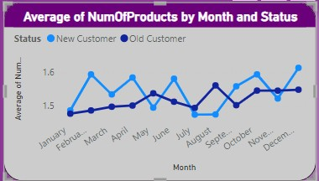

2. **Product Affinity Study: Which bank products or services are most commonly used together, and how might this influence cross-selling strategies?**

the analysis reveals that the majority of customers primarily utilize one bank product or service, with a smaller proportion opting for two services. Specifically, most customers are observed to use a single product or service, while a subset of customers engage with two distinct services.

**Cross-selling strategies**

1. leveraging insights from the distribution of product usage among customers, the bank can design more effective cross-selling strategies that are tailored to individual preferences, thereby increasing customer satisfaction, loyalty, and overall profitability of the bank's product portfolio.

2. By maintaining regular contact and providing relevant updates, the bank can position itself as a trusted financial partner and advisor, making customers more inclined to explore additional offerings.

3. For customers using a single service, personalized offers and recommendations can be provided based on their transaction history, demographics, and behavioral patterns to encourage the adoption of additional products.

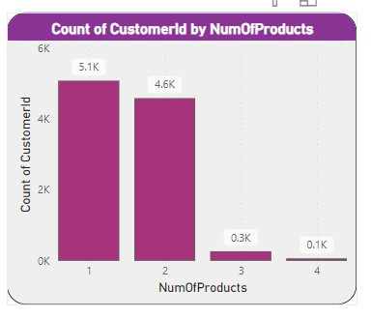

3. Geographic Market Trends: How do economic indicators in different geographic regions correlate with the number of active accounts and customer churn rates?

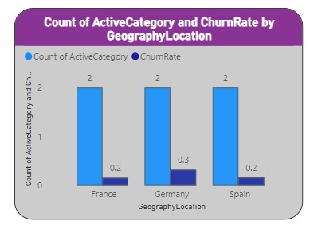France exhibits the highest number of active accounts, yet its customer churn rate remains notably high compared to other regions, where churn rates are relatively lower despite lower active account counts.

**Relationship Between Active Accounts and Churn Rate:**

1. Observation: There appears to be an inverse relationship between active account counts and churn rates.

2.Insight: As the count of active customers increases (e.g., in France), the churn rate tends to decrease. This suggests that a stronger presence of active accounts may contribute to lower churn rates.

4. **Risk Management Assessment: Based on customer profiles, which demographic segments appear to pose the highest financial risk to the bank, and why?**

**1. Financial Risk Metrics:**

1. Metrics: High credit utilization, low credit scores, etc.

2. High credit utilization is identified as a financial risk metric, indicating a potential risk of financial loss for the bank.

**Gender-Based Insights:**

1. Observation: Churn rates are nearly equal for both genders.

2. Insight: Credit utilization is higher for females compared to males. This suggests that while churn rates are similar, there may be a gender-specific financial risk associated with higher credit utilization among females.

**Age-Based Insights:**

1. Observation: Churn rate and credit utilization are higher for the age category of 50 and above.

2. Insight: This age category is identified as falling under financial risk to the bank. The higher churn rate and credit utilization in this category may indicate potential financial challenges and increased risk for bank**.**

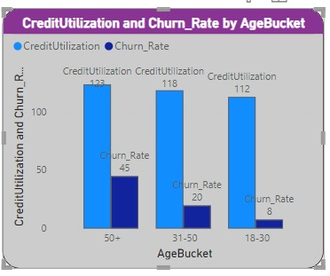

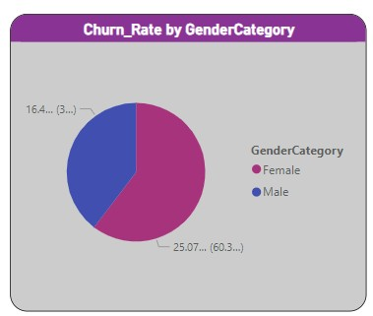

**5.Customer Tenure Value Forecast: How would you use the available data to model and predict the lifetime (tenure) value in the bank of different customer segments?**

**1. Tenure Value Forecast Based on Age Category and Gender:**

1. Observation: The average tenure time is highest among males in the age group of 31 to 50.

2. Insight: This suggests that, on average, male customers in the age range of 31 to 50 tend to have a longer tenure with the company compared to other age categories and genders.

**2. Tenure Value Forecast Based on Age Category and Location:**

1. Observation: The average tenure time is highest in France for the age group of 31 to 50.

2. Insight: Customers in the age group of 31 to 50 located in France, on average, have the longest tenure compared to other age categories and locations.

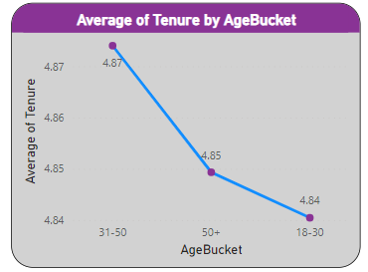

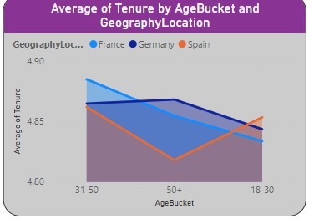

**6. Marketing Campaign Effectiveness: How could you assess the impact of marketing campaigns on customer retention and acquisition within the dataset? What extra information would you need to solve this?**

We can identify impact using various segments like churn rate, age group, locations, and retention to see that we need some more information

1. Details about marketing campaigns: Type, duration, channels used, etc.

2. Customer interaction data during the campaign period.

3. Information on any changes in products or services during the analysis period.

4. Feedback or survey data from customers regarding their experience with the bank and its marketing efforts.

**7. Exit Reasons Exploration: Can you identify common characteristics or Customer trends among customers who have exited that could explain their reasons for leaving?**

**1. Gender Disparity**:

More females tend to exit than males.

**2. Single Product Usage:**

Those who exit are primarily using only one product.

**3. Age-Related Churn:**

The churn rate is higher for individuals aged 50 and above.

**4. Trend in ExitCount**:

ExitCount has shown an upward trend since 2016, with a significant increase of 75.00% (282 exits) in the last three years.

**5. Churn Rate Discrepancy Between Customer Categories:**

Churn_Rate is higher for Older Customers (age category 50 and above), specifically mentioned as 21, compared to New Customers (age category 20), which is denoted as 20.

**8 Are 'Tenure', 'NumOfProducts', 'IsActiveMember', and 'EstimatedSalary' important for predicting if a customer will leave the bank?**

**1. Number of Products:**

Customers using only one product have the highest chance of leaving, as most exited customers fall into this category**.**

**2. Tenure:**

Tenure is crucial for understanding customer loyalty. It helps differentiate between older and new customers, providing insights into which category has the highest churn rate.

**3.IsActiveMember:**

The activity level of customers, as indicated by 'IsActiveMember,' is inversely proportional to the churn rate. Higher activeness suggests a lower churn rate for that category.

**4. Estimated Salary:**

Estimated salary is identified as an important factor. The average estimated salary for both older and new customers is approximately the same, potentially influencing the churn rate**.**

9.Utilize SQL queries to segment customers based on demographics and account details.

I used Geographic location as a customer segment for demographics and account details I used the isactivemember count

|  |  |  |  |
| --- | --- | --- | --- |
| GeographyID | GeographyLocation | number_of_customers | active_count |
| 1 | France | 5014 | 2591 |
| 2 | Spain | 2477 | 1312 |
| 3 | Germany | 2509 | 1248 |

**10.How can we create a conditional formatting setup to visually highlight customers at risk of churn and to evaluate the impact of credit card rewards on customer retention?**

We can go to format visual tab then in values then in cell element we can do conditional formatting to a column, used various charts to show conditional formatting

**Churn Risk Analysis (Table Visualization):**

Formatting Approach: Utilized the "Format Visual" tab and applied conditional formatting within the "Values" section.

Key Metrics: Displayed counts of customers categorized into "HIGH" and "LOW" churn risk.

Insights: Easily identified and compared the number of customers at different levels of churn risk.

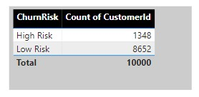

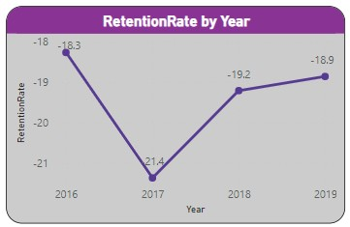

11. **What is the current churn rate per year and overall as well in the bank? Can you suggest some insights to the bank about which kind of customers are more likely to churn and what different strategies can be used to decrease the churn rate?** 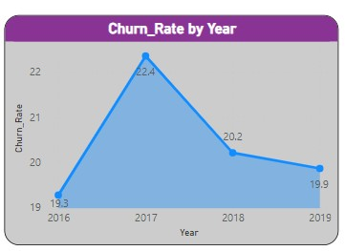

12. **Create a dashboard incorporating all the KPIs and visualization-related metrics. Use a slicer in order to assist in selection in the dashboard**

In Power BI, you can create a dashboard with all the KPIs and metrics linked to visualization along with a slicer for selection by following these steps:

import Data: Take in the relevant information, including the measurements and KPIs you want to visualize, into Power BI.

Create Examples: For every KPI and measure, create a unique visualization (such as a pie chart, line chart, or bar chart). Customize the images as necessary to properly communicate the content.

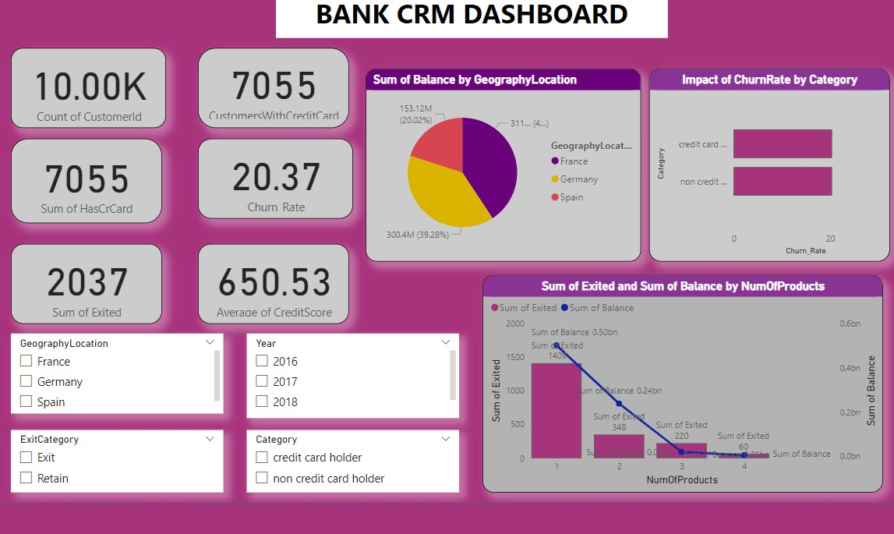

13. **How would you approach this problem, if the objective and subjective questions weren't given?**

* If the objective and subjective questions were not given, the approach to the problem would focus on understanding and analysing the CRM bank dataset to derive insights and identify key factors influencing customer exits.
* Begin by exploring the dataset to understand its structure, variables, and relationships. Identify key variables such as customer demographics, account details,
* Conduct descriptive analysis to summarize the dataset and identify key trends, patterns, and distributions the dataset based on various factors such as demographics, product usage, and interaction history to identify groups of customers with similar characteristics.
* Analyse the churn rate (percentage of customers who exited) over time and identify any trends or seasonality in customer exits.
* Use visualizations such as bar charts, line charts, pie charts, and heatmaps to present your findings and insights in a clear and concise manner

**14.In the “Bank_Churn” table how can you modify the name of the “HasCrCard” column to “Has_creditcard”?**

This code changes the name of the "HasCrCard" column to   
"Has_creditcard" in the "Bank_Churn" table. It improves clarity by using a more descriptive name. 